# PeopleSafe - Payment Finding (Locate) a Payment

Process

Money Orders

Related Documents

**Description:** Direction of how to search for a payment made by check, money order, E-check, or credit card when the payment cannot be found within the Transaction History of the member’s account.

|  |
| --- |
| Process |

Perform the steps below to find a payment:

|  |  |  |  |
| --- | --- | --- | --- |
| **Step** | **Action** | | |
| **1** | Access the **Main** screen in PeopleSafe then select the **Transaction History** tab. | | |
| **2** | Click the **Find Payment** button. | | |
| **3** | Select the appropriate tab for the payment type. | | |
| **4** | Input the search criteria. | | |
| **If searching for a payment made by…** | **Then use one of the following search criteria combinations…** | |
| Check/Money Order | * Post Date From and To, Check Number and Check Amount.   **OR**   * Routing Number, Account Number and Check Number.   Refer to the Money Orders section below for additional tips for searching for money orders. | |
| E-Check | Routing Number and Account Number.  **Note:** The Post Date From and To and Dollar Amount fields are optional but will allow you to narrow the search results if needed. | |
| Credit Card | * Post Date From and To, Card Type, Last 4 digits of Card, and Dollar Amount.   **OR**   * Credit Card Type and Full Credit Card account number. | |
| **5** | Click the **Search** button and review the Search Results. | | |
| **If the payment is…** | **Then…** | |
| Located | Perform one of the following steps: | |
| **If the payment is by…** | **Then…** |
| Check | Consult with [Senior Team (016311)](https://thesource.cvshealth.com/nuxeo/thesource/#!/view?docid=9eef064d-c7d7-42f7-9026-1497496b4d51) to have the check transferred to the member’s account. |
| E-Check or Credit Card | Send a [Payment Dispute (004578)](https://thesource.cvshealth.com/nuxeo/thesource/#!/view?docid=ba2c70ed-7f0c-4779-98b6-9bc1eb9bbb1f) task to have the payment transferred. |
| Not located | Advise member that the payment is not found in our system.   * Refer to [Unapplied Payment (024619)](https://thesource.cvshealth.com/nuxeo/thesource/#!/view?docid=4e75a235-2097-43a9-8ba3-90d4bb6abc44) for the current procedures for Payment Not Found. * Open a [Payment Dispute Task (004578)](https://thesource.cvshealth.com/nuxeo/thesource/#!/view?docid=ba2c70ed-7f0c-4779-98b6-9bc1eb9bbb1f). * Include the full information and check amount, check #, date issued, and date the check cleared bank. | |
| **6** | Provide the member with a receipt for their payment, if requested. Refer to [Statement – Invoice Copy Request (017800)](https://thesource.cvshealth.com/nuxeo/thesource/#!/view?docid=f5f11c92-6544-4d2c-b064-27cd5a910b0b). | | |

Top of the Document

|  |
| --- |
| Money Orders |

Money orders have an account and routing number as well as a check number. Sometimes, due to the shape and size of the money order, the correct fields are not picked up by the scanner making it difficult to find it in the system.

When the scanner cannot pick up the check number, it will add a check number of 888888888. If you are having trouble finding a money order, use the 888888888 check number, date range, and amount.

Below is an image of the **Find a Payment** screen, showing a search for $50.00 money orders received within a two-week timeframe.

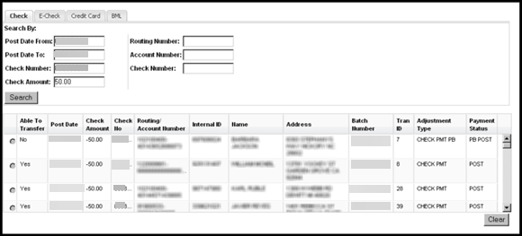

Top of the Document

|  |
| --- |
| Related Documents |

[Customer Care Abbreviations, Definitions and Terms (017428)](https://thesource.cvshealth.com/nuxeo/thesource/#!/view?docid=c1f1028b-e42c-4b4f-a4cf-cc0b42c91606)

**Parent Document:** [Customer Care Internal and External Call Handling (CALL-0049)](https://policy.corp.cvscaremark.com/pnp/faces/DocRenderer?documentId=CALL-0049)

Top of the Document

Not to Be Reproduced or Disclosed to Others without Prior Written Approval

**ELECTRONIC DATA = OFFICIAL VERSION / PAPER COPY = INFORMATIONAL ONLY**